FEMALE - TRUDI STOUT (AUS)

Achievements 2013

1st 2013 SRA Australian Speed and Marathon Championships OPEN WOMEN Marathon 1st 2013 SRA Australian Speed and Marathon Championships 20 – 25 Women Speed

1st 2013 Inaugural Australian Water Ski Racing Championships Series OPEN WOMEN 1st Won all 4 Australian Selection Races and chosen as Australia’s No. 1 Open Women’s Competitor
1st 2013 Women’s Formula 1 Division, International Diamond Race
1st 2013 Women’s Open World Championships– (only competitor to win all 4 races across all divisions)

2012 NSW Female Skier of the year
Trudi is well respected by her peers and officials. She makes herself available to assist at Junior Development Programs in NSW. Trudi is a past Junior World Champion (2007) and a Silver Medallist in 2011 Formula 2 World Championships.

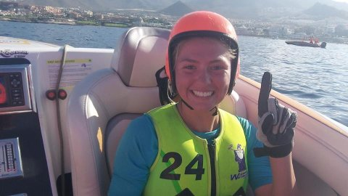

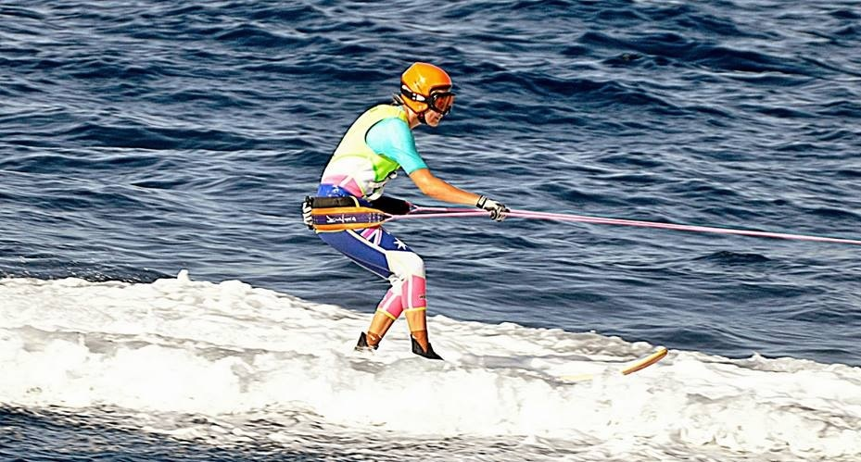
MALE - WAYNE MAWER (AUS)
1st Unlimited Inboard Australian Championships
2nd Outright SOUTHERN 80
1ST Open Men Australian Championship Series
2nd Diamond Race Belgium
1st in 3 out of 4 Australian Selection Races Open Men
1st Open Men 2013 IWWF World Racing Championships

Wayne has been Open Men’s World Champion 3 times – 1997, 2009, 2013. After winning the 1997 Open Men’s World Championship Wayne decided to try wakeboarding and was successful in winning a World Wakeboard Championship. He returned to Ski Racing in 2009 and won 2 more Championships 2009 and 2013. Wayne did not compete in the 2011 Championships. He is very well respected by all in Ski Racing in Australia.

